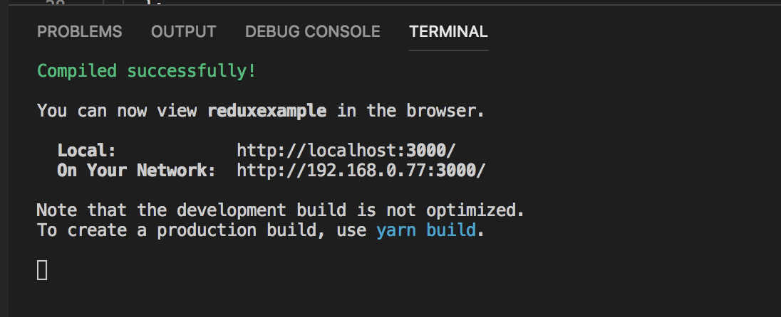

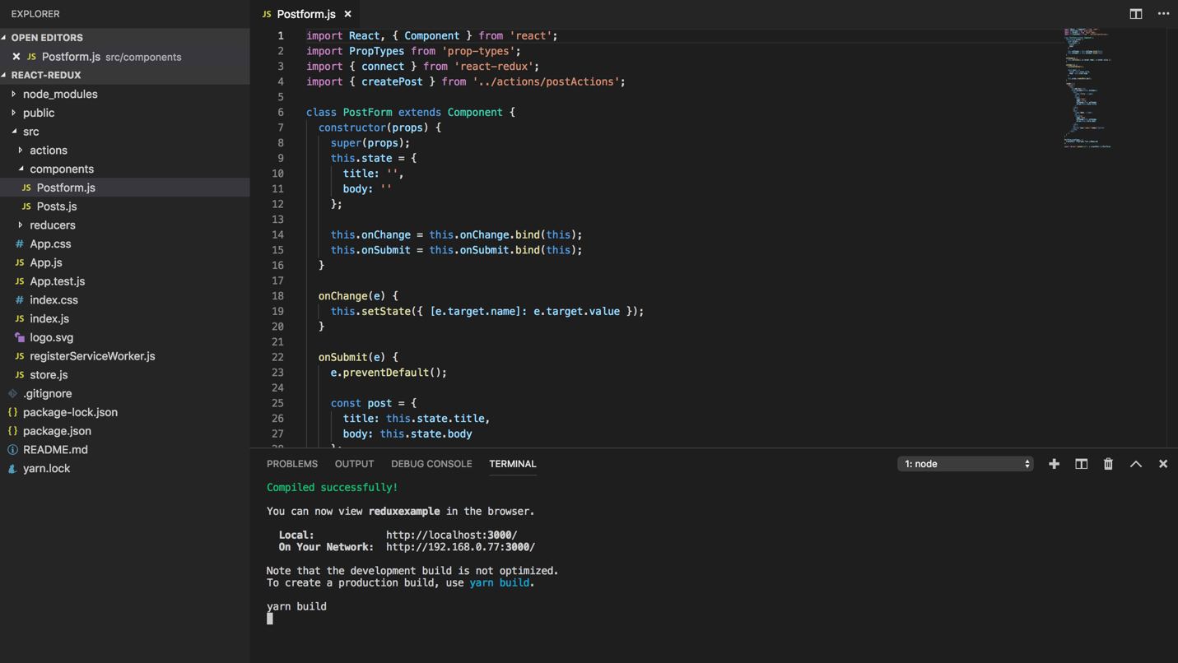

The error was thrown before adding extension for react js and redux js extension. After adding the following has been executed by running following commands.

Npm install

Npm start.

